HEC – Repository for Learning Products/Objects

Pat’s Charge
- Subgroup of 3-4 people to continue discussions
  - Myself
  - Evaluator
  - Teacher
  - Content Expert
  - Repository Host
- Hosting Subgroup …Deana, Jill, Gary, Walter, Gayle
- Design/content Subgroup – Maria, Jill, Deana, Pat, Walter and Gayle

What we promised
- 1) To create an administrative framework and conceptual pipeline for prioritizing, developing,
reviewing, and distributing learning resources on PGR;
  - The content review process that will be similar to that of the eXtension model or the Journal of Natural Sciences Education review processes before content is posted, i.e., an internal review is performed by three qualified people: one content expert, one teacher of the content, and one IT/instructional designer.

- 2) To develop an organized series of learning resources (videos, ebook chapters, images, etc.)
covering priority PGR topics;
  - Learning object topics are listed in Table 1. A conservative estimate is that we will
produce 20 of these objects each year.
  - Each learning object will be a separate chapter within the eBook that will be linked from the PGR Training Resources website (Objective 3).
  - The first priority for content development will be materials needed for the new course modules. Over time, additional content will be developed that covers the subject more intensively. The learning objects that are developed in this HEC proposal will also be used in the Plant Breeding Education for Africa project at ISU https://pbea.agron.iastate.edu/) and the Online Seed Technology Program at CSU (https://www.online.colostate.edu/certificates/seed-technology/).
  - First, subject matter experts convened by the HEC Co-PI’s will determine overall learning goals for each overarching topic area, as well as specific objectives for each learning object. This will help to consolidate efforts and map out critical information to be provided, and the method for acquiring and presenting that information. The HEC Co-PI’s will then make the necessary contacts and provide the coordination needed to develop and acquire the content.

- 3) To establish an online repository to host, organize, and track usage of the developed content;
  - The USDA-ARS Database Management Unit (DBMU) of the National Germplasm Resources Laboratory in Beltsville, MD, will develop and publish a new “Plant Genetic Resources Training Resources” page as part of the NPGS section (https://www.ars- grin.gov/npgs/index.html) of GRIN. Updated link at: https://www.ars-grin.gov/

- 4) To develop and offer three 1-credit graduate-level online course modules at CSU on PGR
conservation and their use in plant breeding and genetics;
- 5) To disseminate the developed materials broadly to communities of interest, including Tribal
Colleges and 1890 land-grant universities.

Key Features
- Able to be used with less reliable internet
- Able to use with multiple devices?
- Teachers/trainers with various LMS (or no LMS) able to use within their contexts?
- Quality Matters type of reviews/indications
- How do people find this site? Marketing/communitcations
- IP ownership
- Language translations?
- Assessments
- Certificates/badging?
- Data analytics (Jill’s questions)
  - Views and downloads
  - Where are users located?
  - How are learning objects being used?
  - Who are the users?
  - Measuring learning outcomes
  - Longer term impacts
- Potential tools….Pressbooks

Other Repository Examples

Name | URL | Description
Plant Breeding eLearning in Africa | https://pbea.agron.iastate.edu/ | Walter’s!
Plant and Soil Sciences eLibrary | https://passel2.unl.edu/ | UNL based
Science of Agriculture | https://scienceofagriculture.org/index.php | UNM based
Crop Genebank Knowledge Base | https://cropgenebank.sgrp.cgiar.org/ | CGIAR
Merlot | https://www.merlot.org/merlot/index.htm | CA State Univ – full time operation now
Kahn Academy | https://www.khanacademy.org/
PBS Teachers | https://net.pbslearningmedia.org/
National Science Digital Library | https://nsdl.oercommons.org/
PennState Extension | https://extension.psu.edu/

Walter’s: https://pbea.agron.iastate.edu/
- 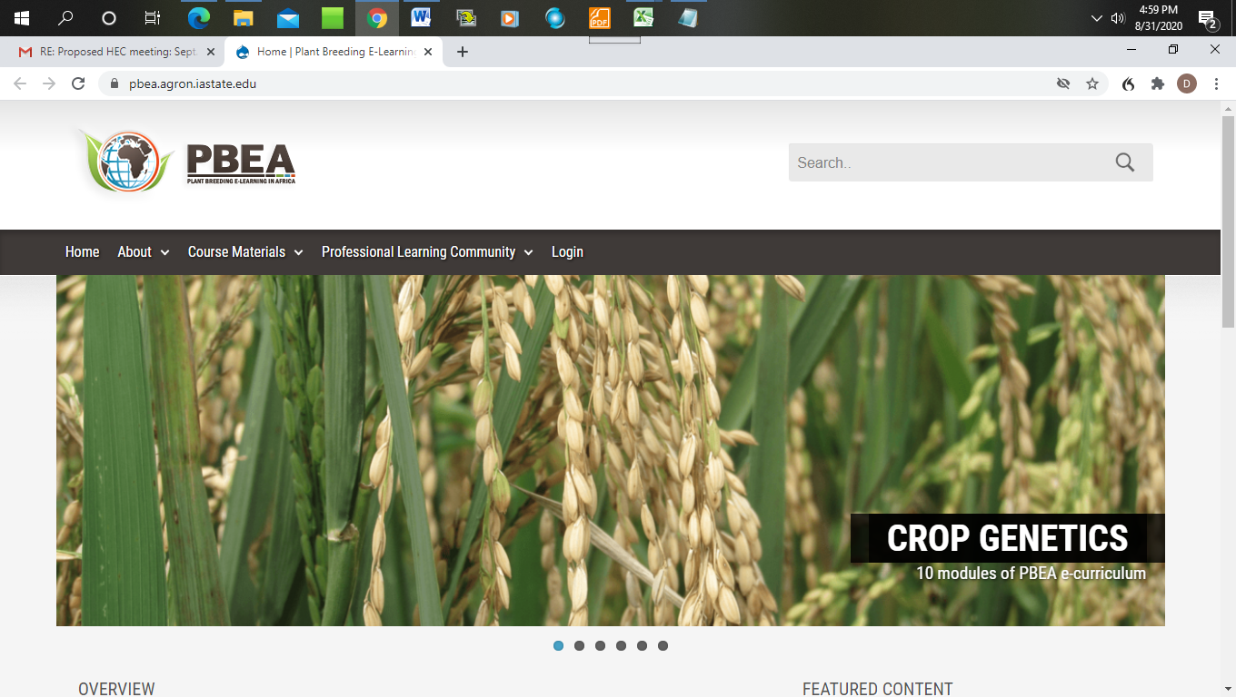
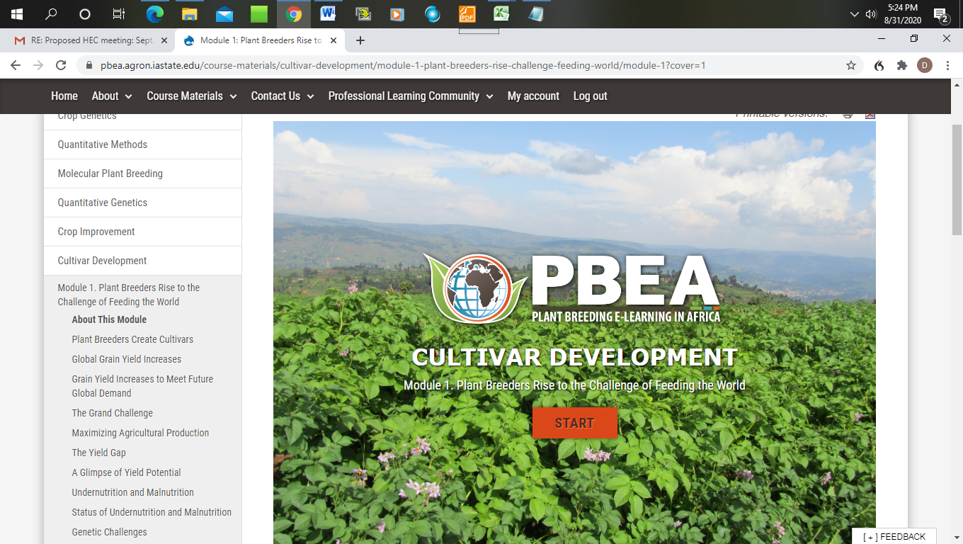

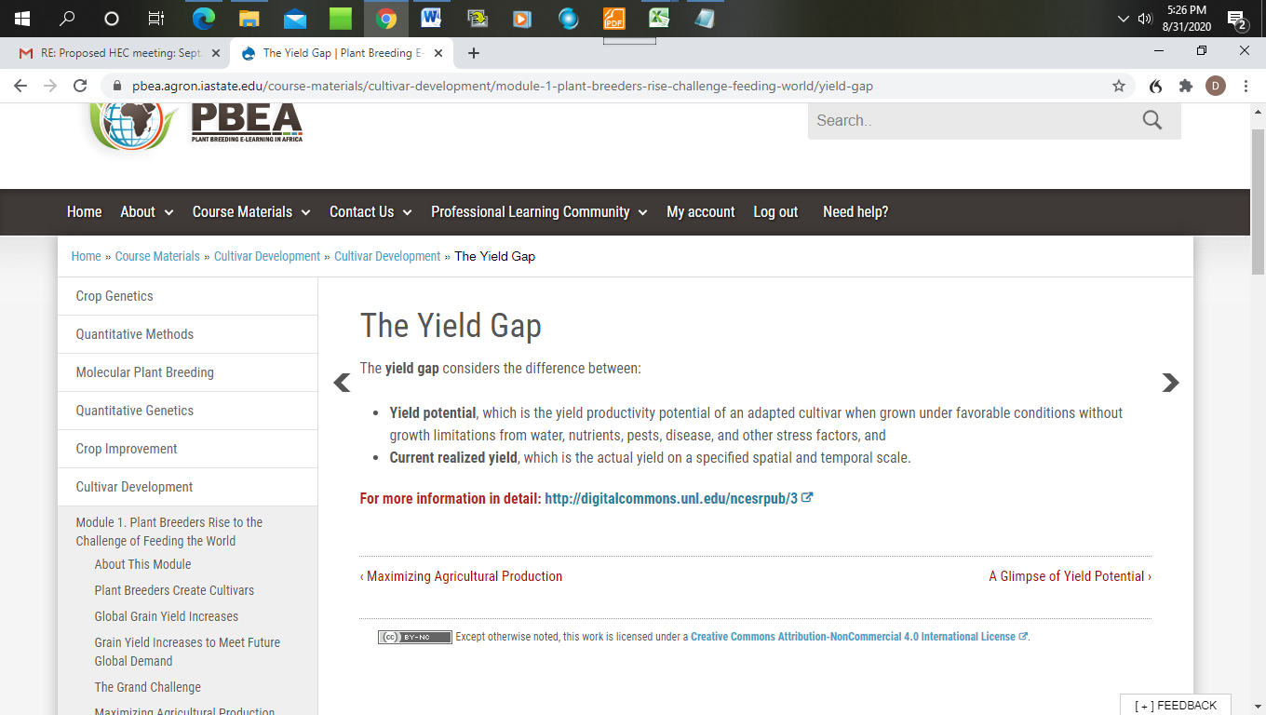
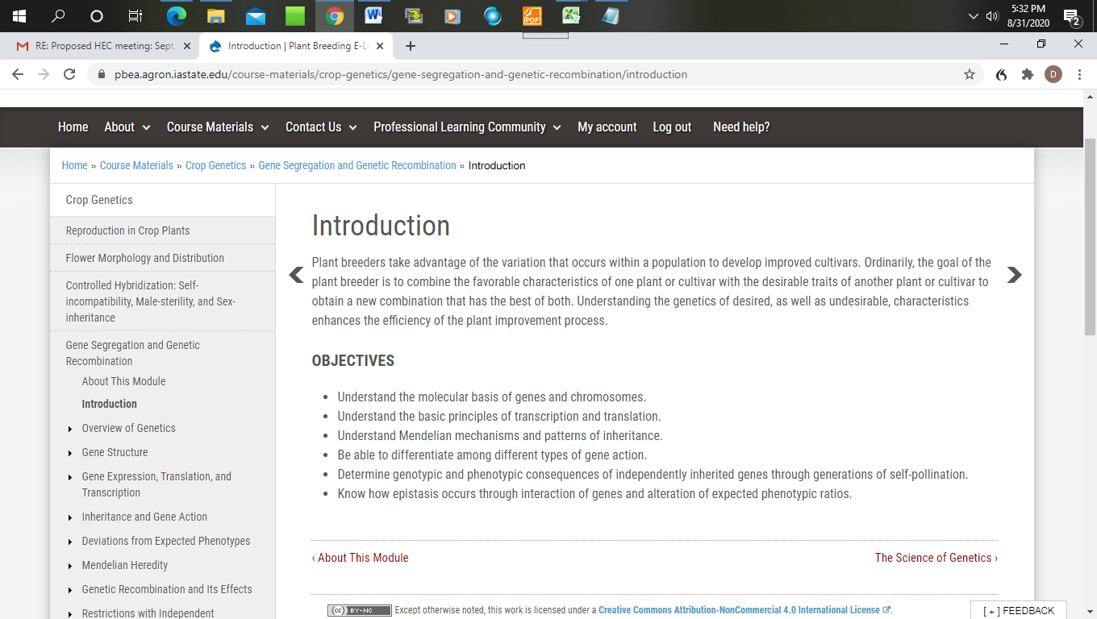

Plant and Soil Sciences eLibrary: https://passel2.unl.edu/

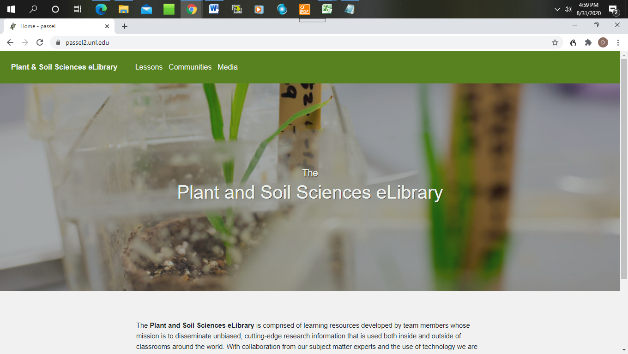
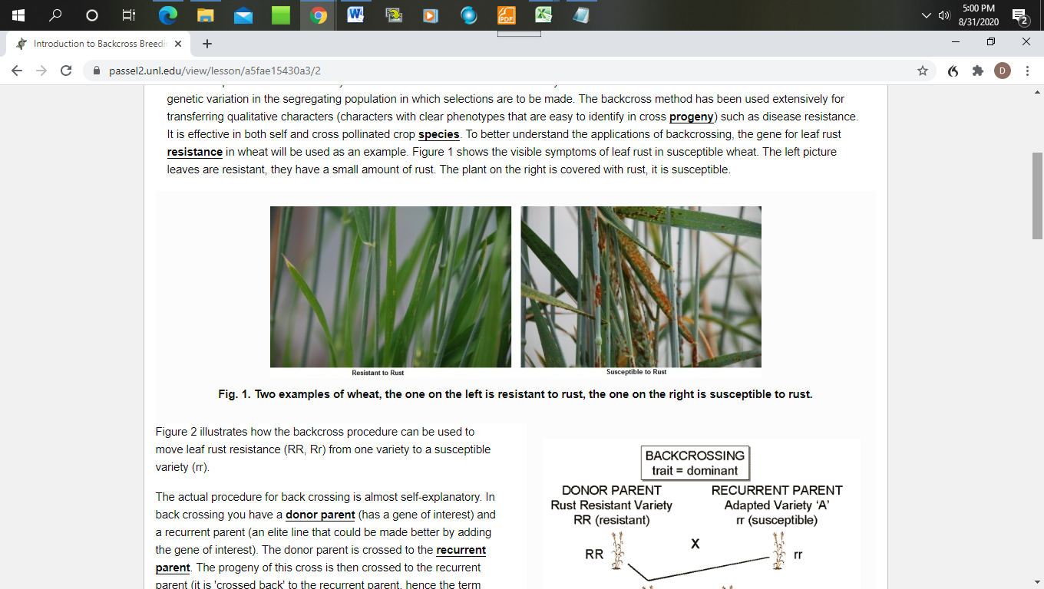

Science of Agriculture https://scienceofagriculture.org/index.php
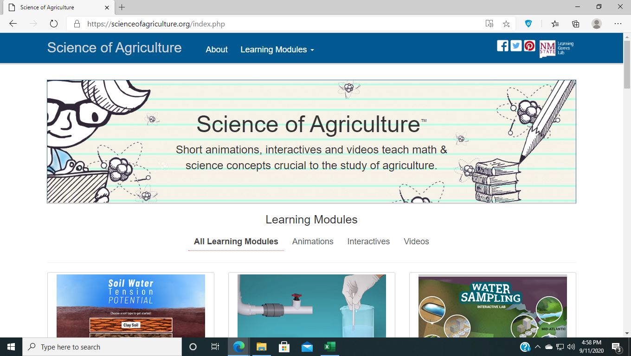

CGIAR Knowledge Base https://cropgenebank.sgrp.cgiar.org/

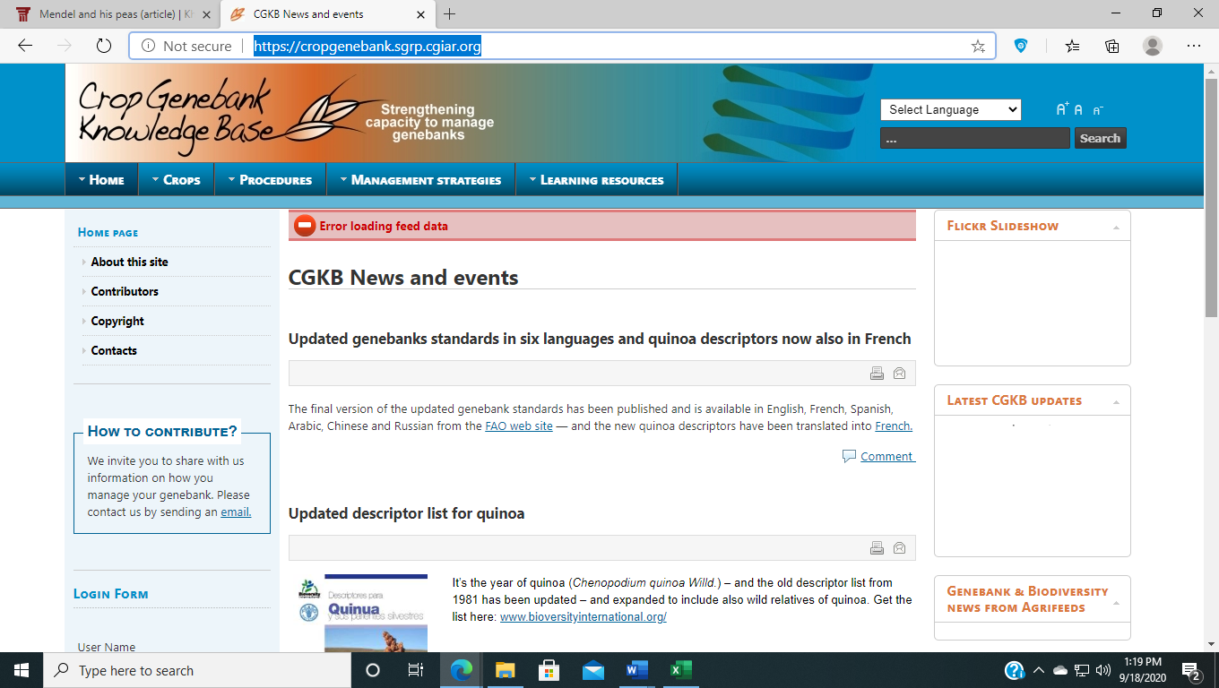

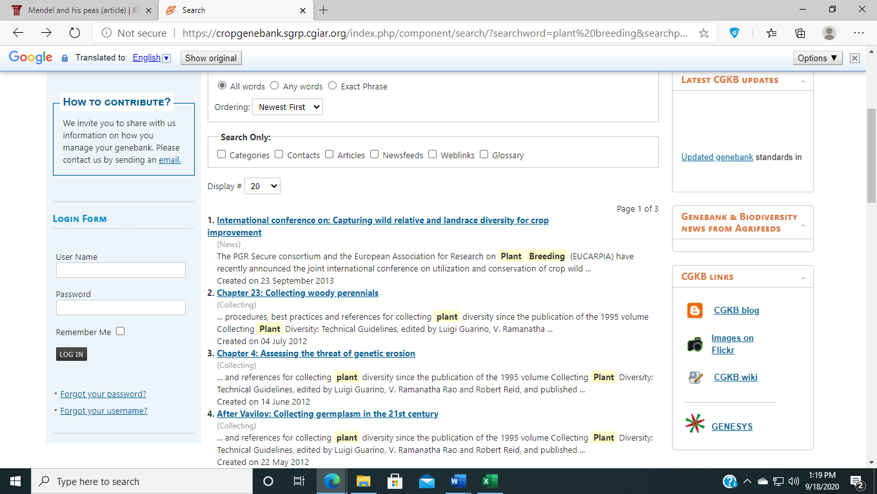

Merlot https://www.merlot.org/merlot/

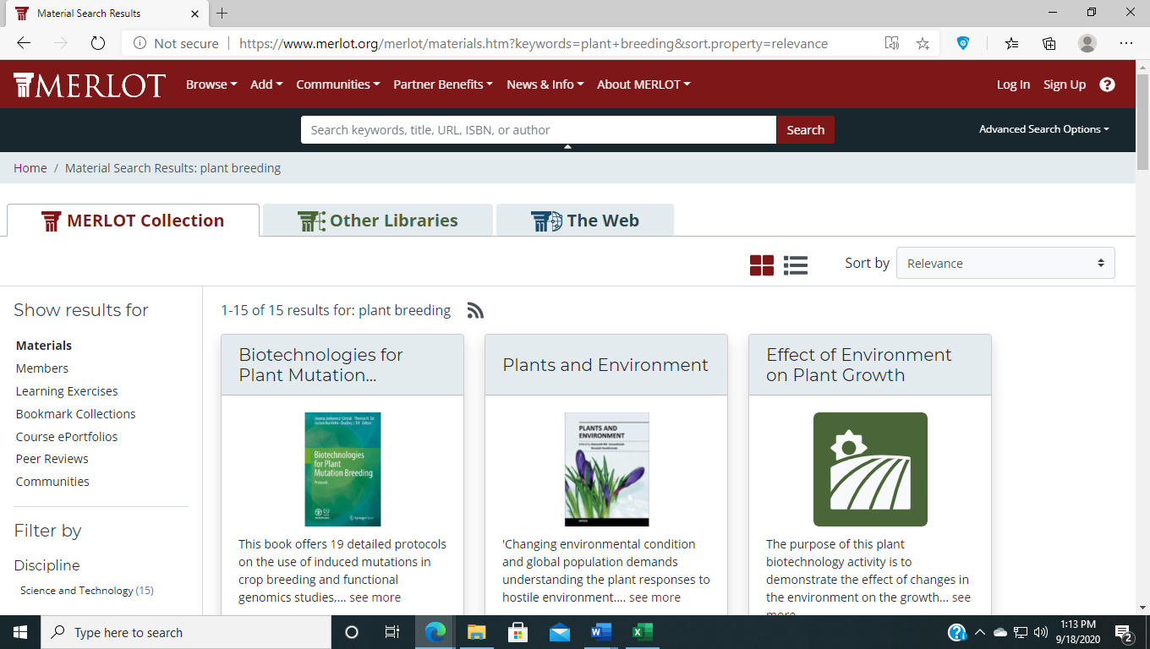

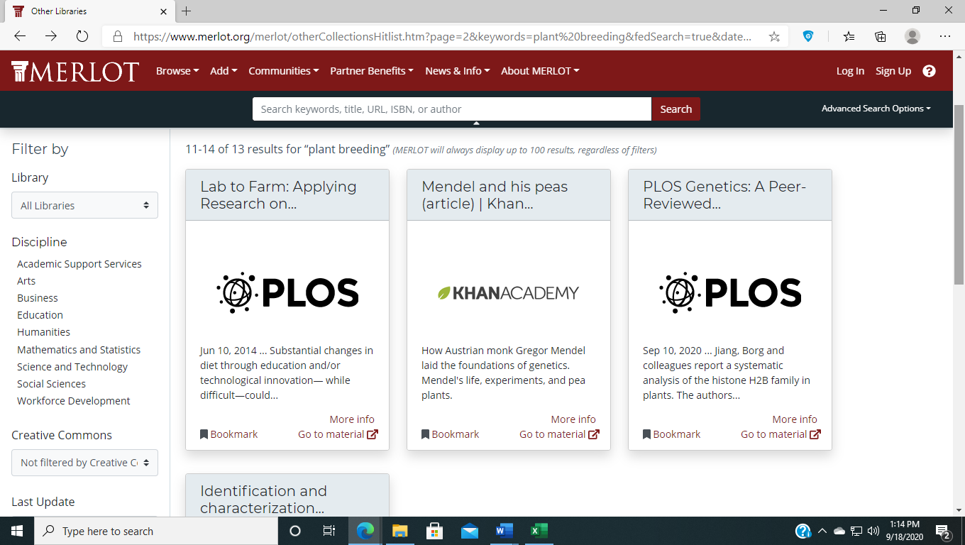

Khan Academy https://www.khanacademy.org/
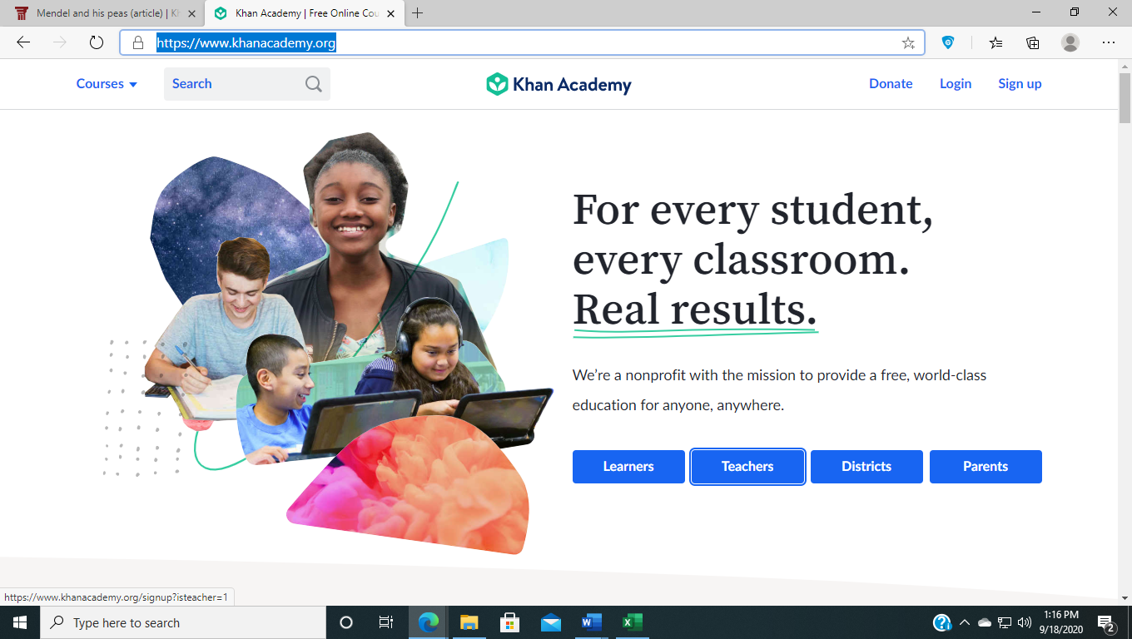

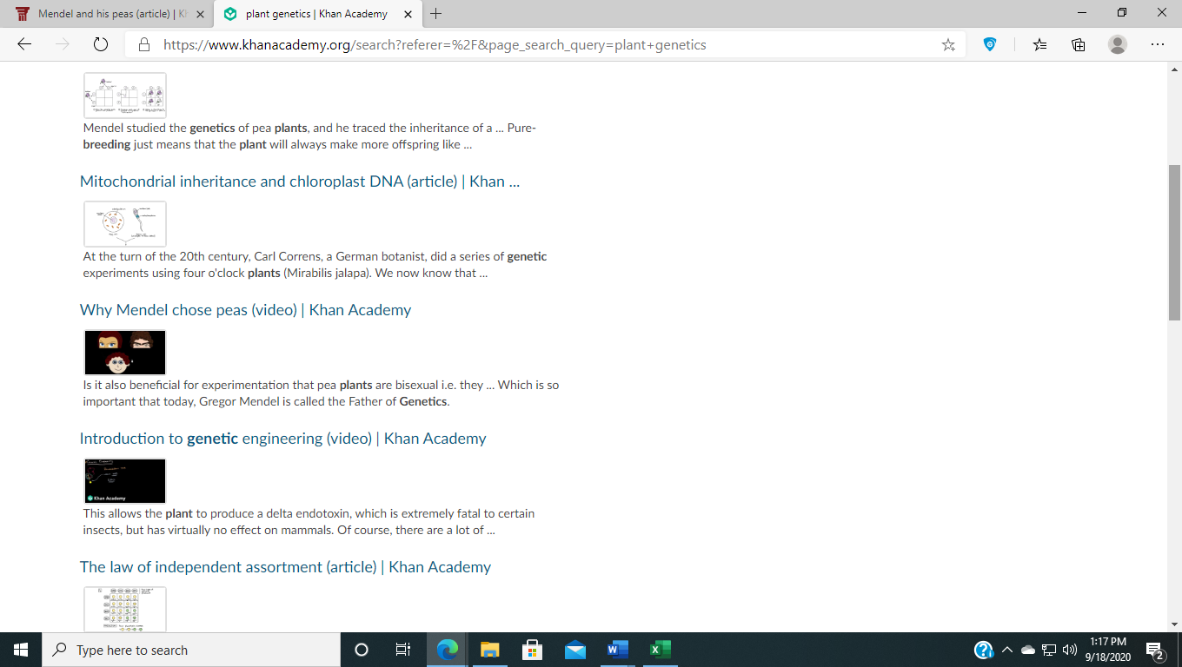

PBS Teachers: https://net.pbslearningmedia.org/
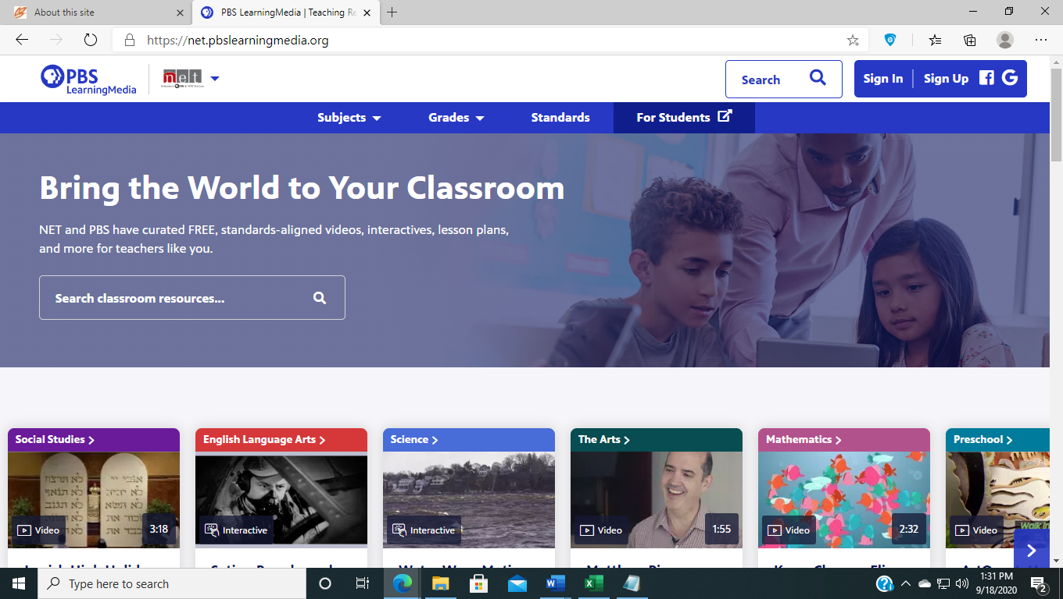

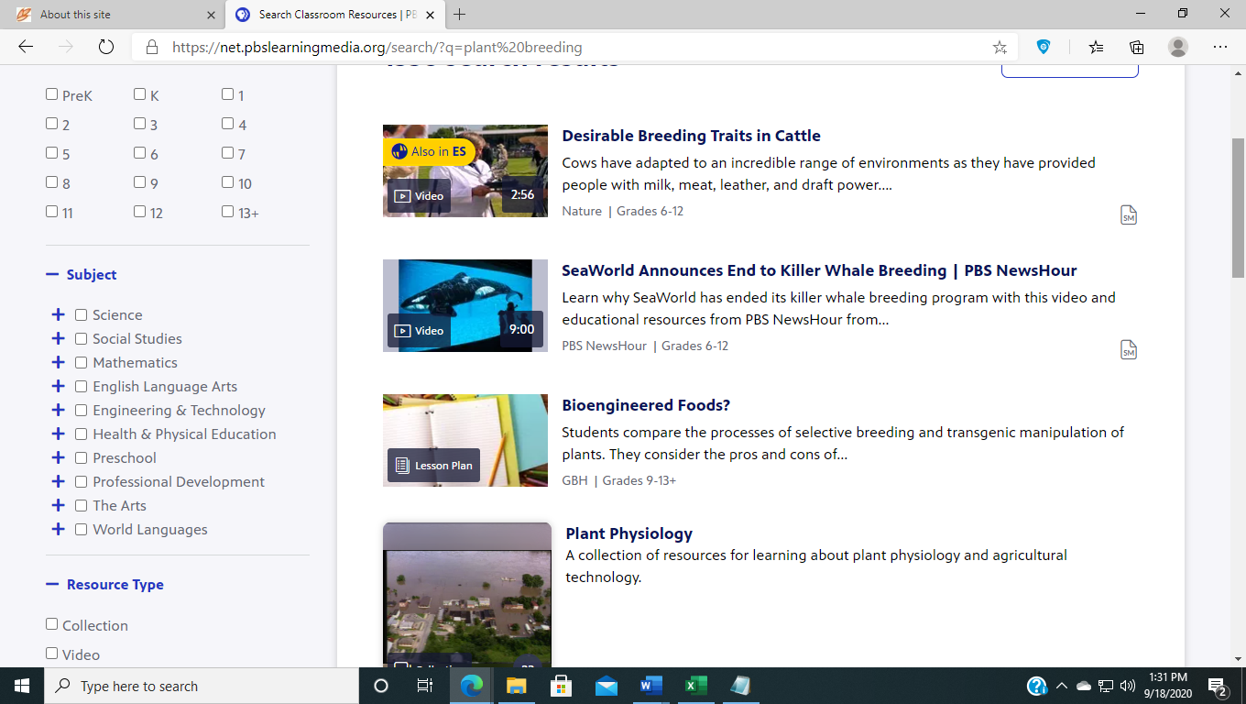

National Science Digital Library https://nsdl.oercommons.org/
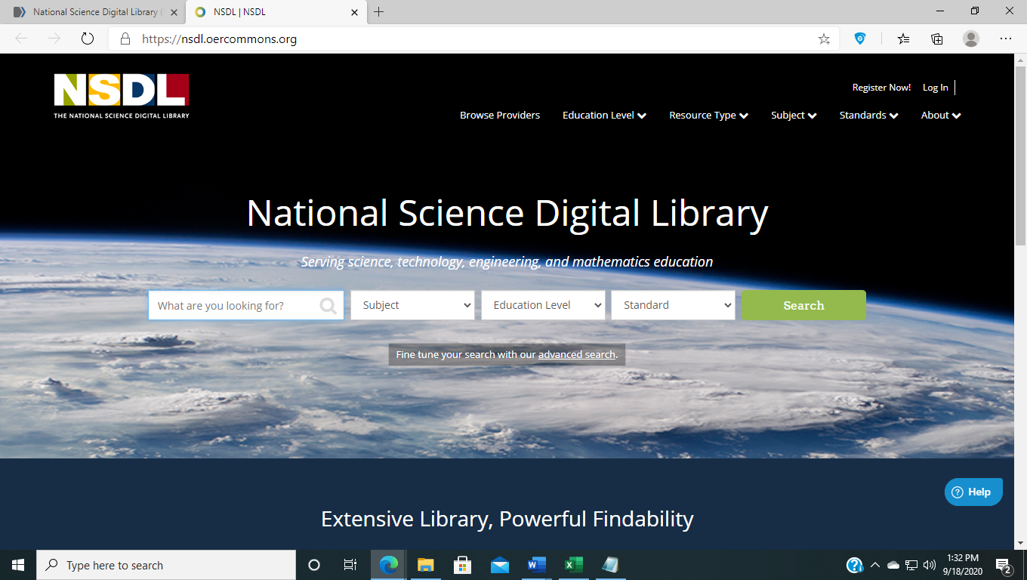

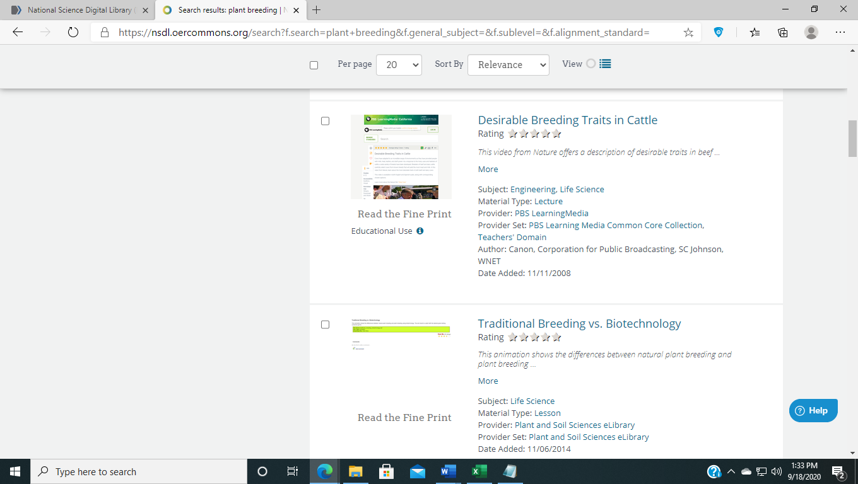

PennState Extension - https://extension.psu.edu/

